0.Execute all scripts from thedevops-cloud-documents-channel.
Defining variables:-

#!/bin/bash
# Example of defining variables

a=Imran
b=Afzal
c=’Linux class’

echo "My first name is $a"
echo "My surname is $b"
echo ‘My surname is $c’
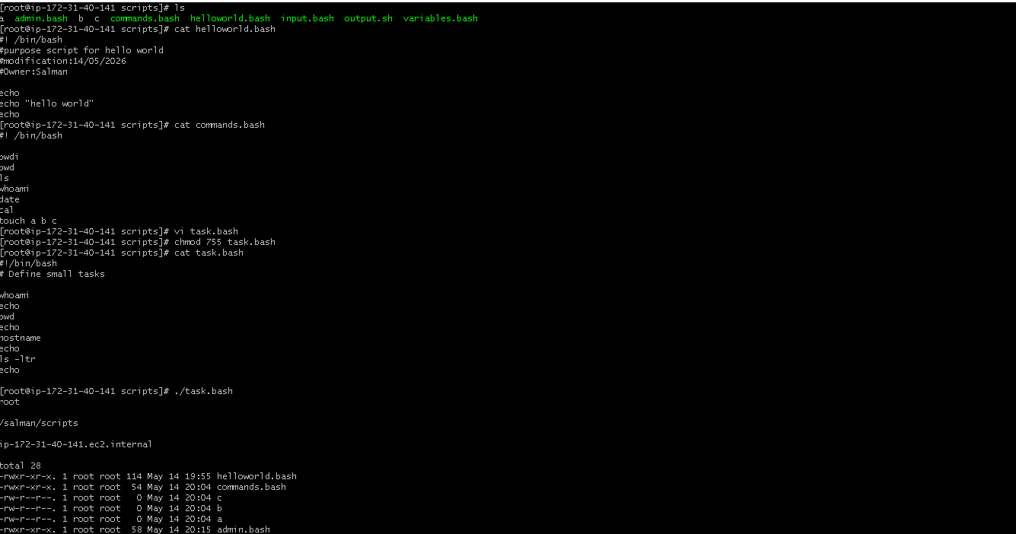

Scripts to run commands within:-

#!/bin/bash
# Script to run commands within

clear
echo "Hello `whoami`"
echo
echo "Today is `date`"
echo
echo "Number of user login: `who | wc -l `"
echo

Read input and perform a task:-

#!/bin/bash
# This script will rename a file
echo Enter the file name to be renamed
read oldfilename
echo Enter the new file name
read newfilename
mv $oldfilename $newfilename
echo The file has been renamed as $newfilename
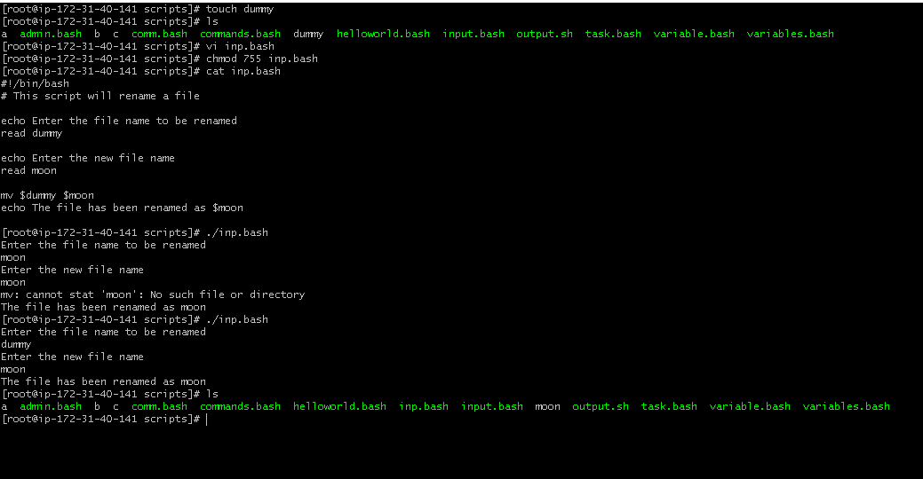
case Scripts:
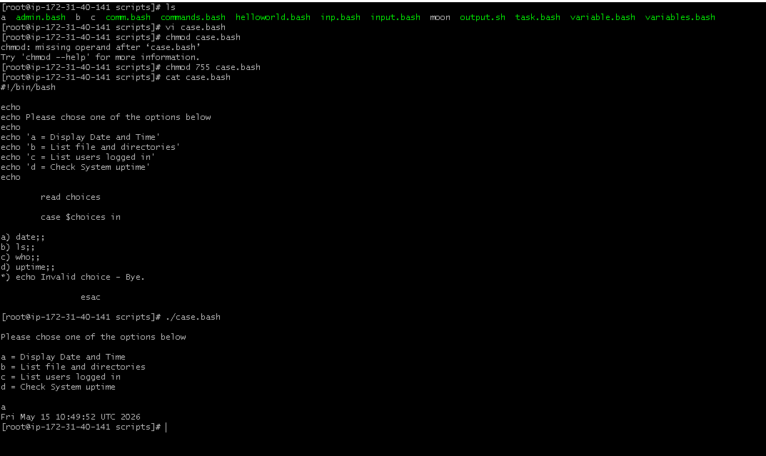
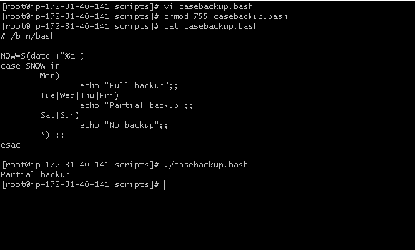

do-while Script:-
Script to run for a number of times
#!/bin/bashc=1
while [ $c -le 5 ]
do
echo "Welcone $c times"
(( c++ ))
done
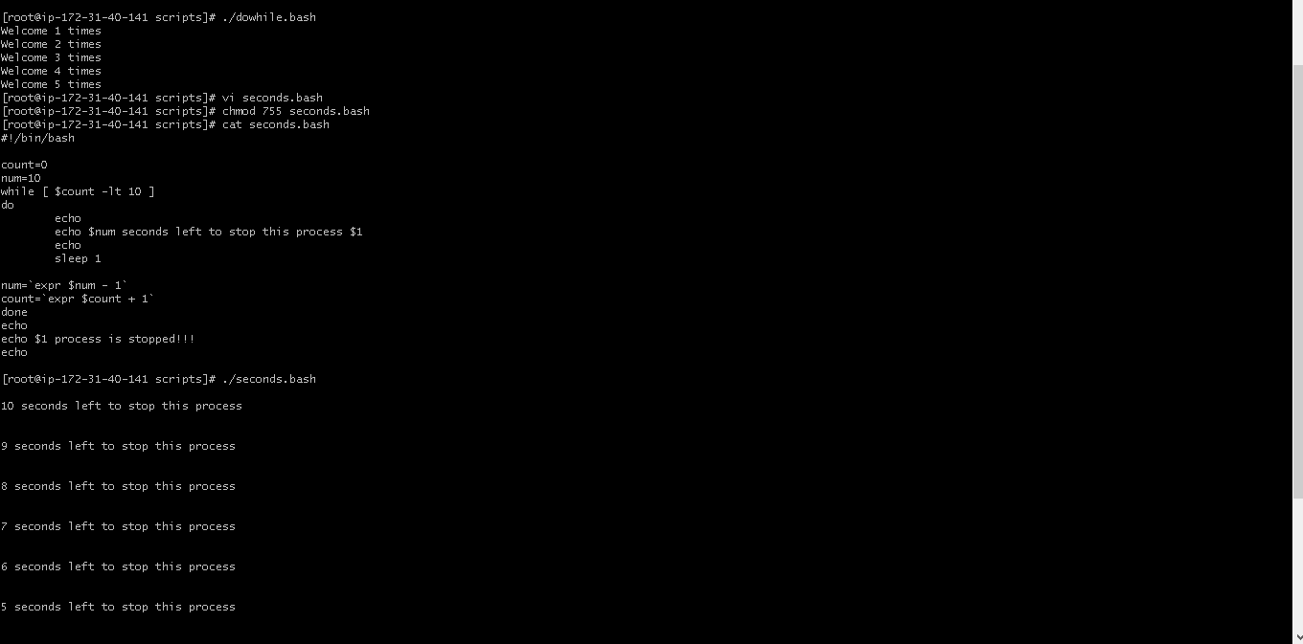

Return exist status if file exist:-

#!/bin/bash
ls -l /home/iafzal/check
if [ $? -eq 0 ]
then
echo File exist
else
echo File does not exist
fi
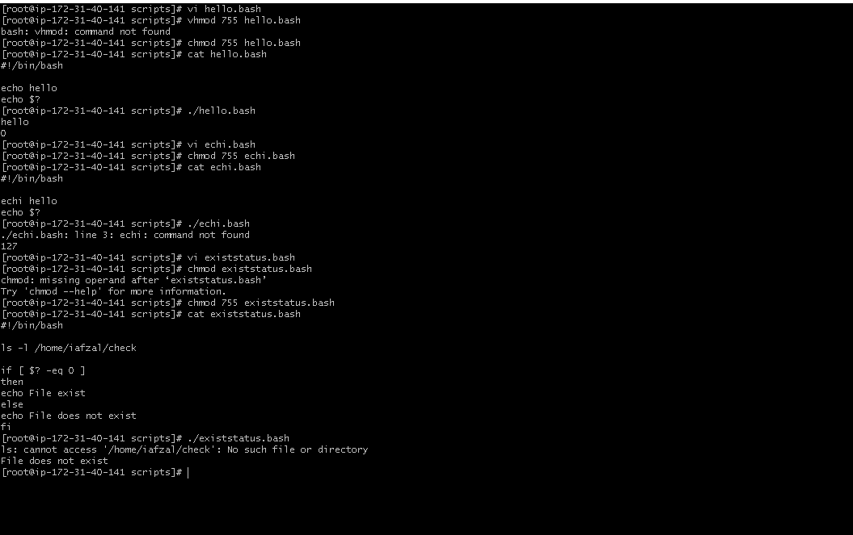

for loop Scripts:
Simple for loop output
#!/bin/bash
for i in 1 2 3 4 5
do
echo "Welcome $i times"
done
Simple for loop output
#!/bin/bash
for i in eat run jump play
do
echo See Imran $i
done

for loop to create 5 files named 1-5
#!/bin/bash
for i in {1..5}
do
touch $i
done
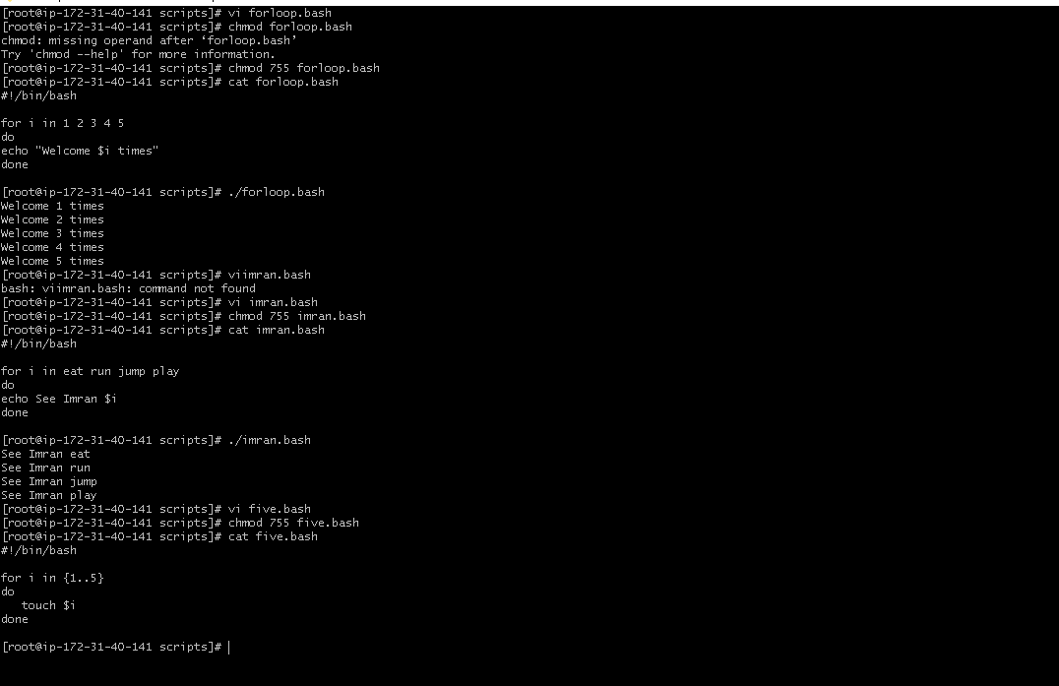

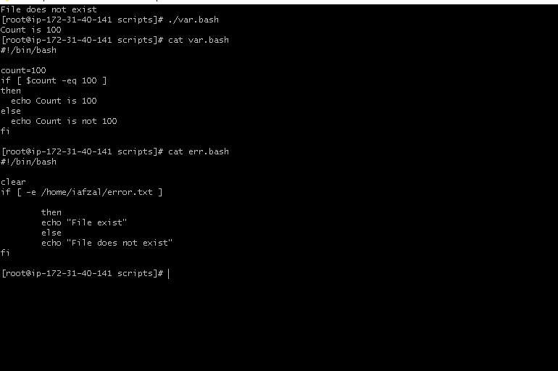
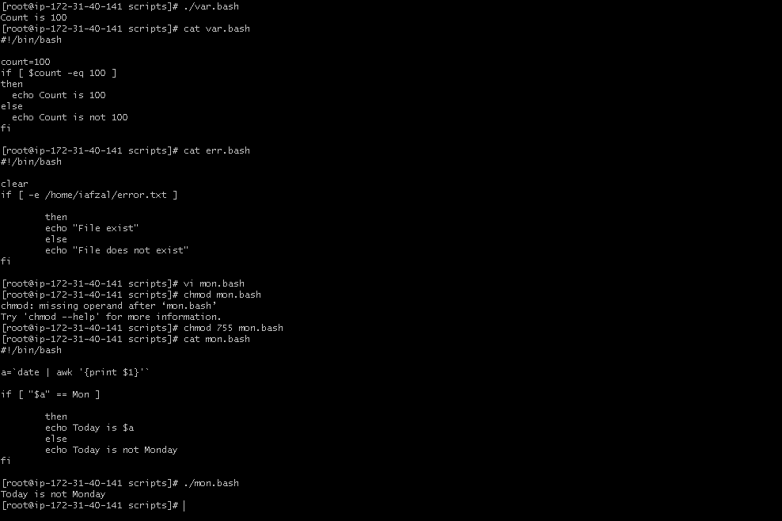

Check the response and then output:-

#!/bin/bash
clear
echo
echo "What is your name?"
echo
read a
echo
echo Hello $a sir
echo
echo "Do you like working in IT? (y/n)"
read Like
echo
if [ "$Like" == y ]
then
echo You are cool
elif [ "$Like" == n ]
then
echo You should try IT, it’s a good field
echo

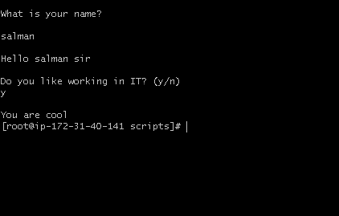
Fi

1.Create a bash script to check if a directory is available or not.

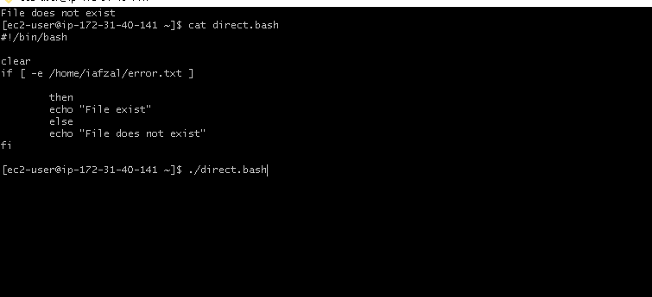

2. Create a bash script to create multiple files
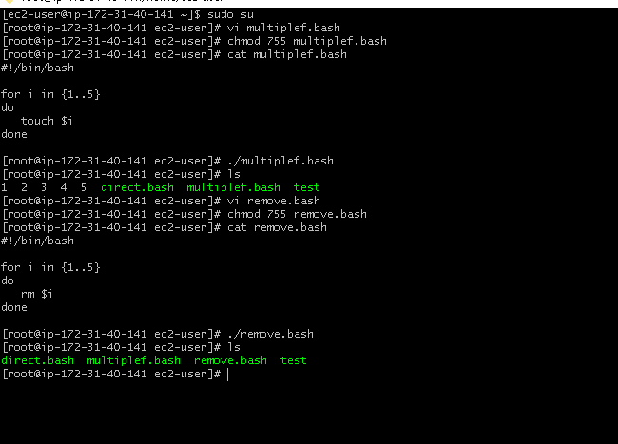

3. Create a bash script to take a backup of a directory:-
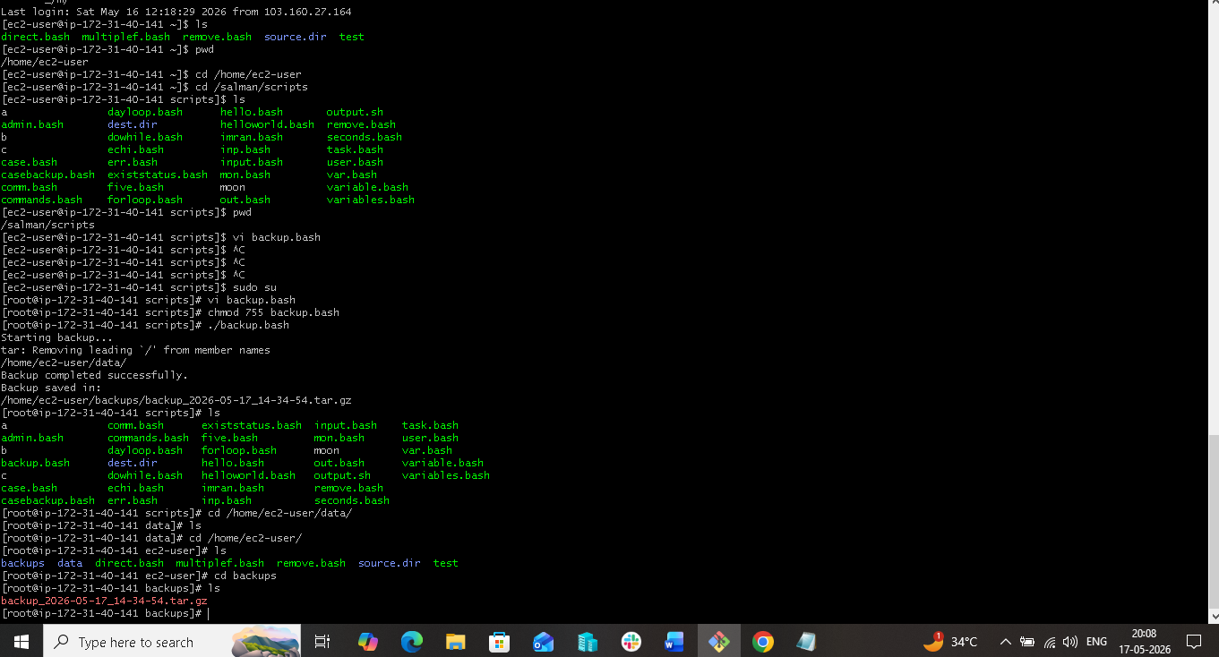

4. Create a bash script to install Nginx on an EC2 server.

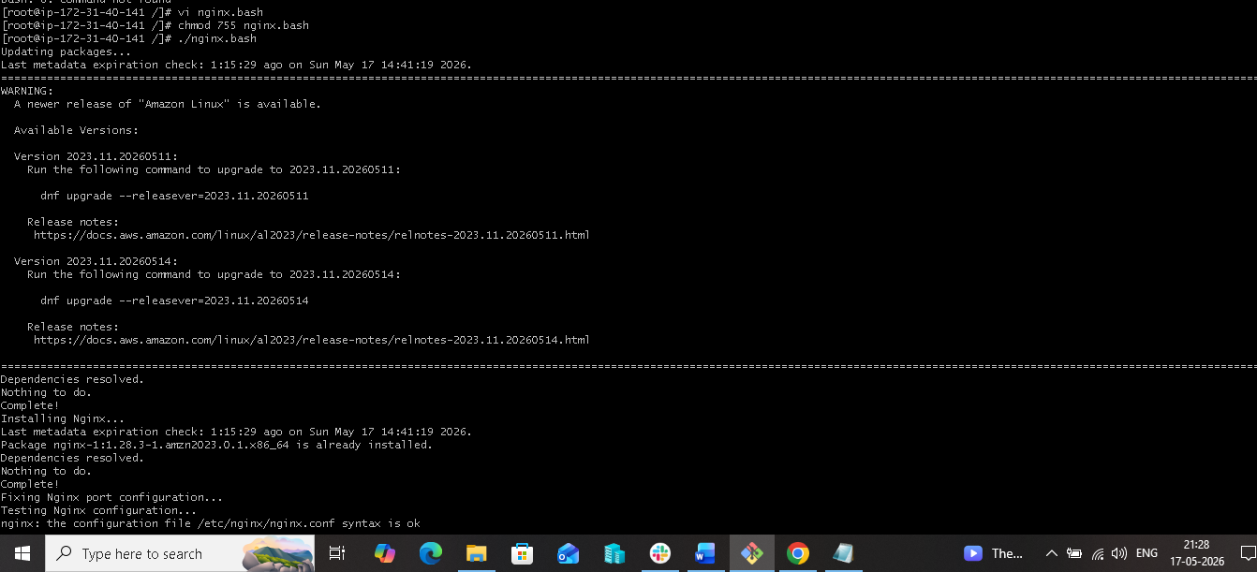

5. Create a bash script to install Apache Tomcat on an EC2 server

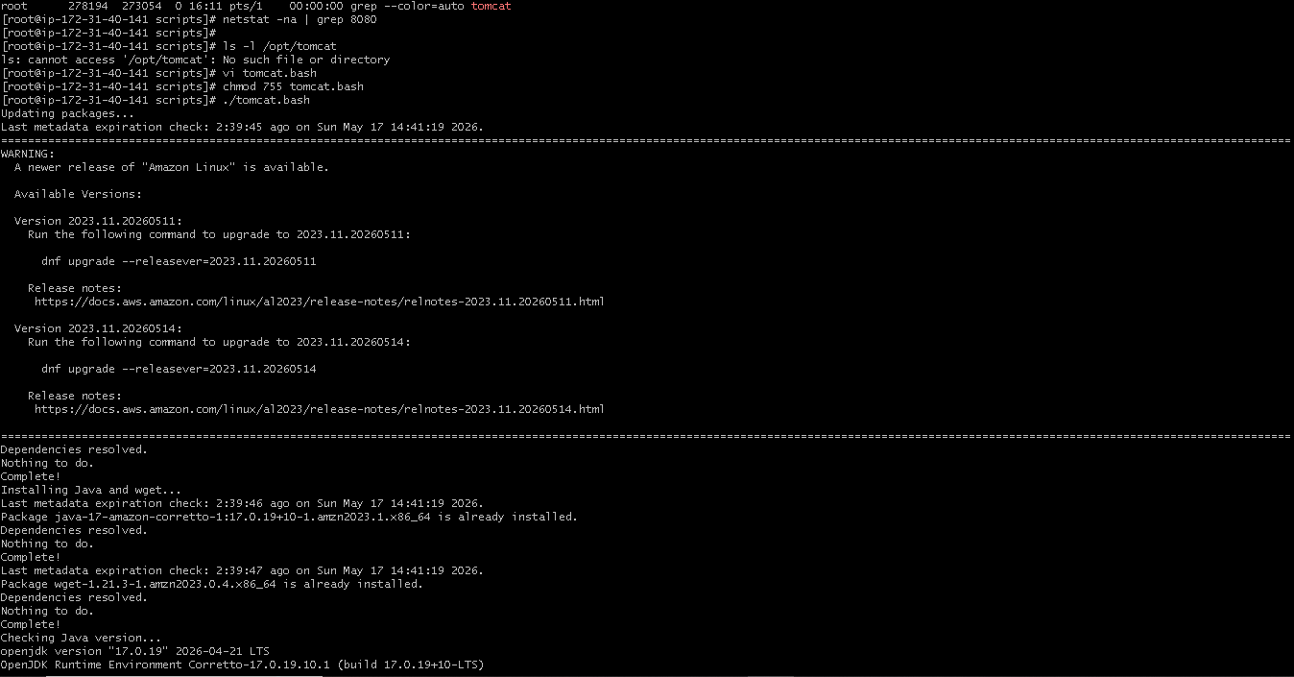

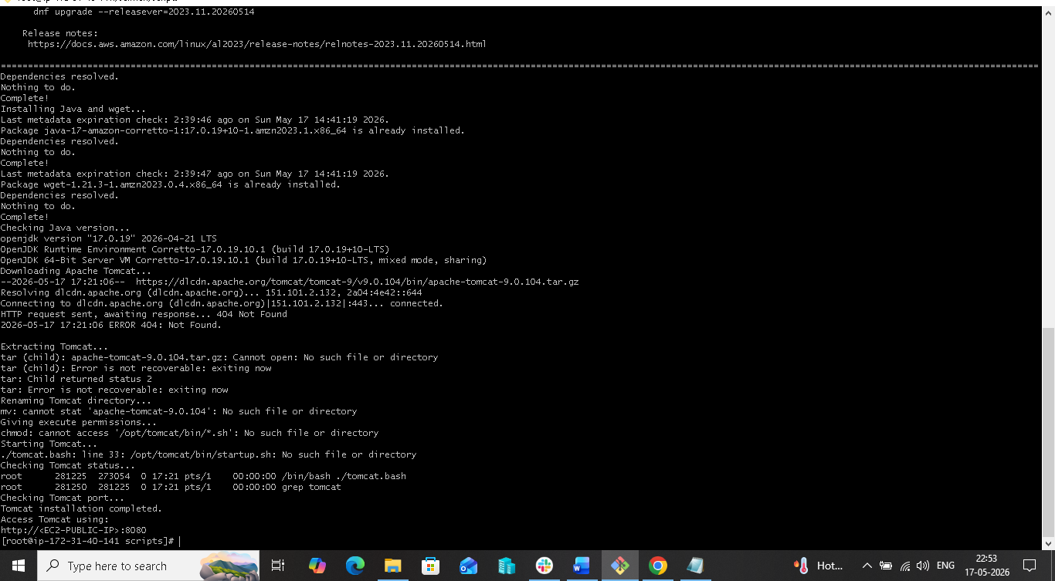

6. Create a bash script to check if the Nginx service is running, if not running then script should start the service.
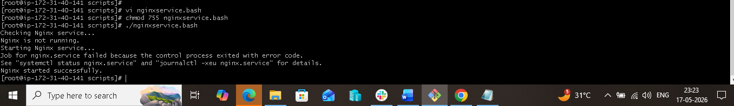

7. Create a bash script for a calculator
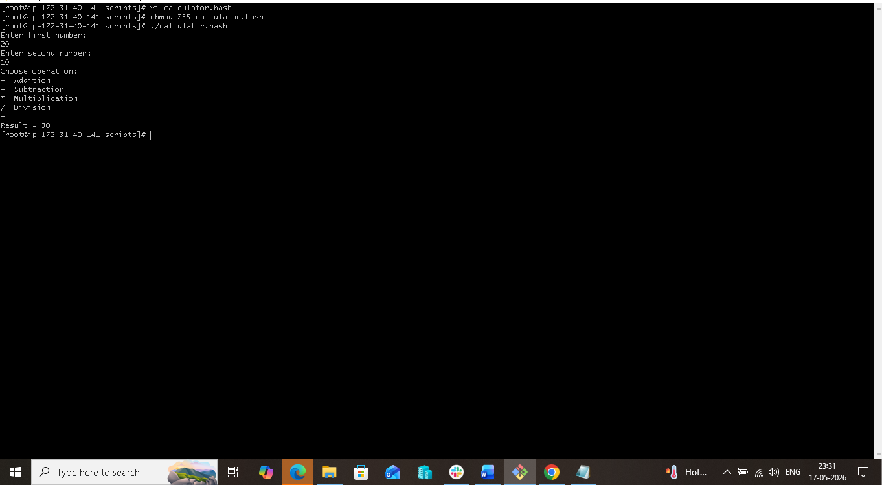

8. Create a bash script to check if a directory exists, if not then create a directory

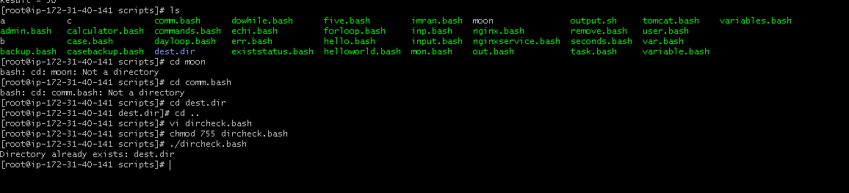

9. Create a bash script to delete the last 3 lines of a file.
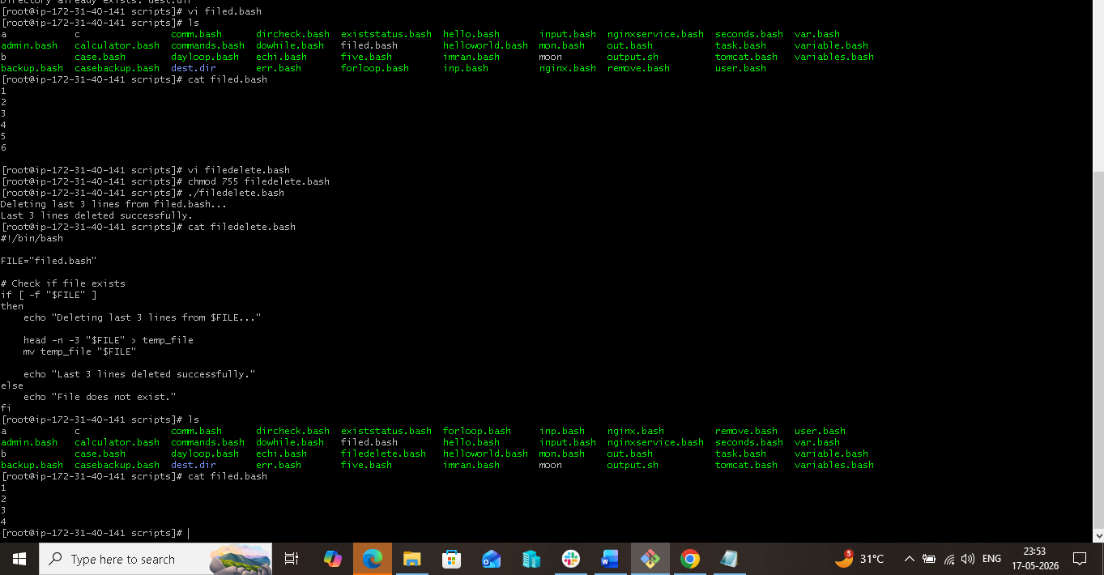

10. Bash script to monitor cpu and if it is more than 80% then send email notification.
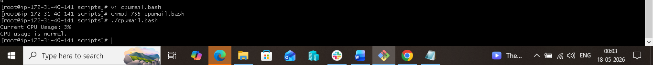

11. Bash script to monitor disk space and if it is more than 80% then send email notification.
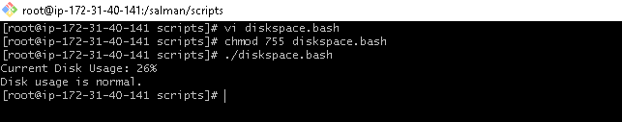

12. Bash script to monitor memory and if it is more than 80% then send email notification.
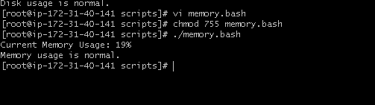

Crontab Entries:-
- April 5th Midnight

- At 05 and 27th minutes of 9, 10, 11hours every day
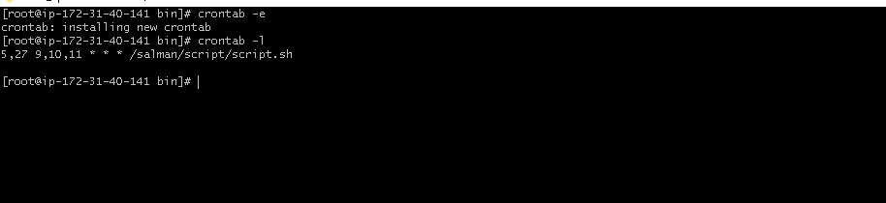

- 34 minutes of 9th hour on 15th August
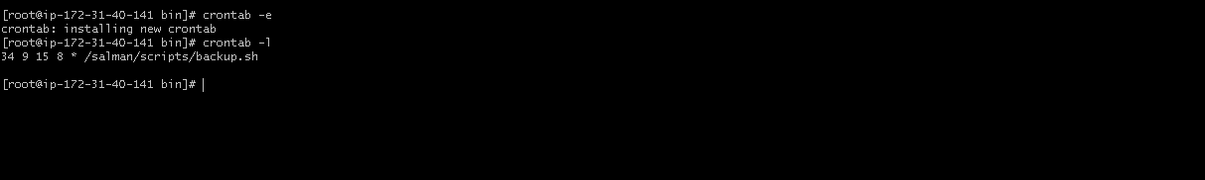

- Every midnight
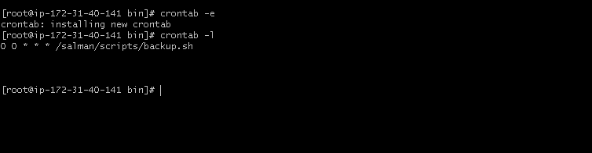

- Every Weekend (Saturday night 11:59 PM)

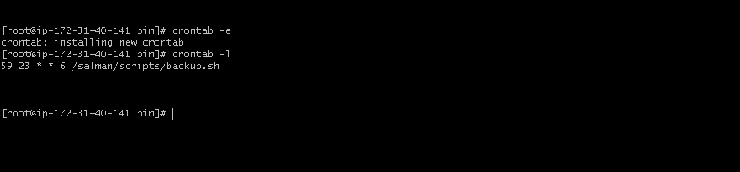

- After every reboot

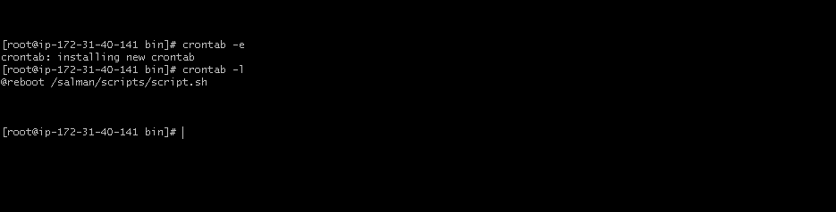

Github link:-

https://github.com/shaiksalman0058/Bash-script-Task

